**DIGITAL NURTURE 4.0 DEEP SKILLING JAVA FSE-WEEK1**

**NAME: SIVITHA GUNASEKARAN   
SUPERSET ID: 6413354**

**WEEK 1: DESIGN PATTERNS AND PRINCIPLES  
TASK 1:**

**Implementing the Singleton Pattern**

**Scenario:**

You need to ensure that a logging utility class in your application has only one instance throughout the application lifecycle to ensure consistent logging.

**Steps:**

1. **Create a New Java Project:**
   * Create a new Java project named **SingletonPatternExample**.
2. **Define a Singleton Class:**
   * Create a class named Logger that has a private static instance of itself.
   * Ensure the constructor of Logger is private.
   * Provide a public static method to get the instance of the Logger class.
3. **Implement the Singleton Pattern:**
   * Write code to ensure that the Logger class follows the Singleton design pattern.
4. **Test the Singleton Implementation:**
   * Create a test class to verify that only one instance of Logger is created and used across the application.

**My Screenshot proofs: Sample code of Logger.java and LoggerTest.java with output**

**Logger.java**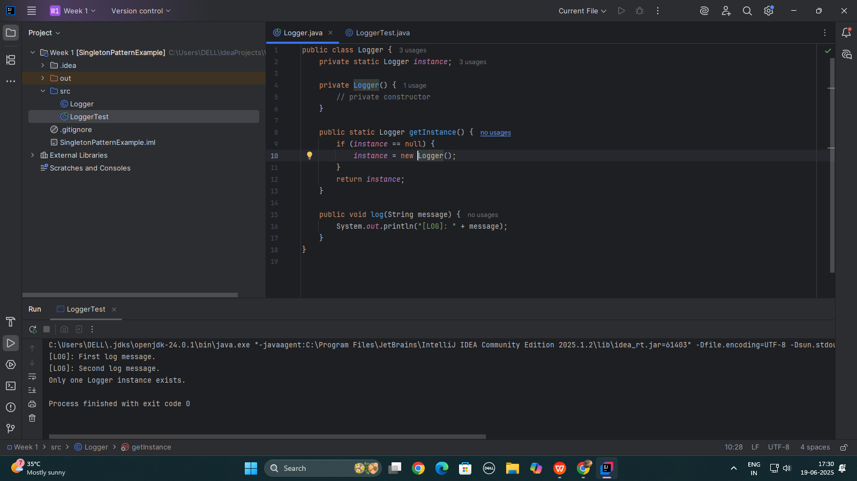

**LoggerTest.java**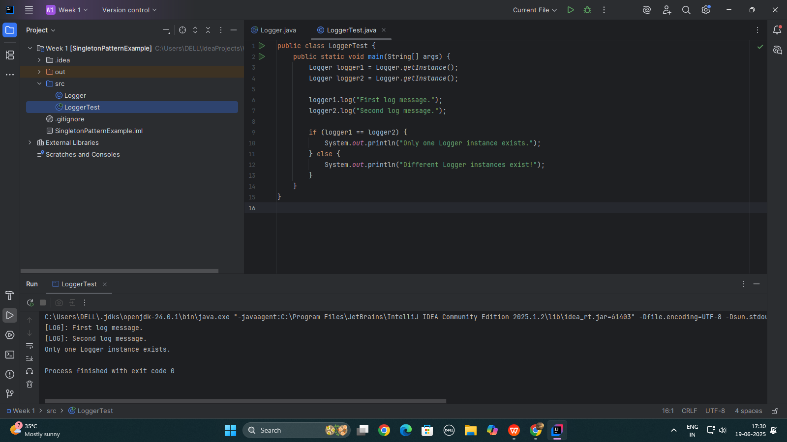

**OUTPUT:**

